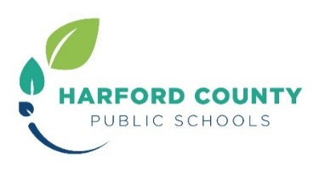
Student Mobile Device Protection Option
Per the Student Mobile Device Agreement, your student has been provided a device to use for instructional purposes. As noted in this agreement, in accordance with Board of Education policy, Use of Equipment/Materials by Students, the parent/guardian will be responsible for all damage or loss to an HCPS owned device, whether in or out of school.
Harford County Public Schools is offering the option to purchase device protection. This fee is per device, per student for the entire school year and is non-refundable. This plan will cover the cost of accidental damage to the device, if submitted for repair with the service tag visible. The plan is available for purchase through January 31, 2023. The cost of the device protection plan is as follows:
- $20.00 if purchased through October 31, 2022 OR
- $50.00 if purchased November 1 through January 31, 2023
If the device service plan is not paid in full by January 31st, the parent/guardian will be issued an invoice if damage occurs. An invoice will be sent to the email on file from StudentDevices@hcps.org. Harford County Public Schools may utilize a collection agency to recoup this cost if not paid. Also note that Harford County Public Schools reserves the right to hold a student and family fully accountable for 100% of the damages should there be repeated, willful and/or malicious damage.
Cost without the device service plan: Repair - $150

Please note: Lost or stolen items ARE NOT covered by the device protection plan.
Parent/guardians will be billed for the replacement cost for lost or stolen items as noted below:

- Charger - $36
- Chromebook/laptop - $300
- Dell Precision laptop - $1,400
- Apple iPad - $39
The student device must be returned at the conclusion of the school year with the service tag visible. Any device not returned will generate a replacement charge listed above.

If you apply and are approved for free and reduced meals, you will automatically receive the device protection plan. The application can be found at https://www.myschoolapps.com/Home/PickDistrict

Purchase the plan here: https://harford.schoolcashonline.com

Any questions can be directed to studentdevices@hcps.org

